MOVIE TICKET BOOKING SYSTEM

Project Report submitted for Software Engineering(CS-206)
Dr. Priyadhashani

K.RANATHI (22STUCHH010770)


Department of DSAI

Icfai Tech (Deemed to be University) HYDERABAD

APRIL, 2024

CHAPTER 1:PROBLEM STATEMENT
The Movie Ticket Booking System has been created with the purpose of allowing users to effortlessly search for movies, browse through available showtimes, choose their desired seats, and make online reservations. At present, buying movie tickets typically involves waiting in physical lines at theaters or dealing with disjointed websites that offer limited features, which can be inconvenient and time-consuming for customers. Furthermore, theaters encounter difficulties when it comes to overseeing seat availability, managing numerous bookings, and offering instant updates. The goal of this system is to enhance the booking process by establishing a smooth, user-friendly, and entirely digital platform that manages ticketing operations from start to finish.
The Movie Ticket Booking System is an online platform where users can effortlessly explore movie options, choose showtimes, secure seats, and complete payments securely, all within a single interface. The system caters to three primary user groups.Customers have the ability to search for movies, choose showtimes, check available seats, complete payments, and receive a booking confirmation.Admin with responsibilities in Theater Management has the ability to add new movies, update schedules, manage seat availability, and view booking reports.Payment Gateway: Seamlessly connects with trusted third-party payment services to manage customer transactions.Characteristics of the System:Users have the option to search and filter movies according to genre, language, showtimes, and location.
Users have the option to select their preferred seats in real time by viewing the available options.Booking Confirmation: Users will receive a confirmation along with ticket details upon completing the payment.Administrative tasks such as adding movies, setting prices, managing schedules, and monitoring booking statistics can be handled by the admin.Smoothly processed payments are guaranteed through a secure payment gateway, safeguarding the privacy of your data.The goal of this system is to make it easier and more efficient to book movie tickets, decrease reliance on physical ticket counters, and enhance theater management through a centralized booking platform.

CHAPTER 2: SYSTEM ANALYSIS

Existing System:
The manual booking process at theaters involves customers visiting the ticket counter in person to purchase tickets, which can lead to prolonged waiting periods, particularly during busy times.Online booking options are limited, as some platforms may not provide real-time updates on seat availability or showtimes, resulting in customers facing incomplete or outdated information.Insufficiently user-friendly seat selection process: Some platforms do not offer the feature of visually choosing seats, which can be essential for movie enthusiasts with specific preferences for certain areas in the cinema.Insufficient Centralized Information: Customers may find it challenging to access all showtimes and availability in one convenient location, especially for theaters with multiple venues.Customer support is limited, offering customers few options for assistance with booking problems, and navigating refunds or cancellations can be intricate.Security concerns arise due to the absence of secure payment gateways in certain systems, leading to worries regarding customer data privacy and payment security.

Proposed Solution

The suggested Movie Ticket Booking System is a centralized, real-time, web-based solution aimed at improving customer experience and simplifying the booking process for theater administrators.Functional Requirements:User Registration and Login feature enables customers to easily register an account, log in, and conveniently manage their booking history.Users should have the convenience of searching for movies based on genre, language, showtime, and location through the Movie Search and Filter feature.Present the Showtime display alongside the availability of seats in real-time for users to easily access.Seat Selection: Users should have the option to pick their seats by selecting them visually from a seat map.Users should have the capability to effortlessly book tickets and complete payments using secure online payment gateways.Confirmation emails or SMS notifications will be sent by the system following a successful booking.Administrators have the capability to add, modify, or delete movies, oversee schedules, and monitor reservations.Functional requirements:Usability is enhanced when the interface is designed to be user-friendly and intuitive.Performance is crucial, with a specific focus on the system's ability to manage heavy traffic, particularly during busy hours.Ensuring reliability is crucial, as real-time seat availability and showtime updates are necessary.

CHAPTER 3: DAIGRAMS
3.1 ACTIVITY DAIGRAM
The activity diagram of the Movie Ticket Booking System illustrates the procedure that a customer needs to go through in order to reserve a movie ticket online. The process commences with the customer logging in or creating an account, then proceeds to browsing for a movie based on genre, date, or location. Once the customer has chosen a movie, showtime, and seats, they can proceed to enter their payment details. Subsequently, the system proceeds to handle the payment. In the event of a successful transaction, it verifies the booking and dispatches a confirmation through email or SMS. Conversely, if the payment is unsuccessful, the system alerts the customer to attempt the transaction again. The diagram elegantly illustrates the steps and various alternative routes, offering a comprehensive overview of the complete ticket booking process, from initiation to conclusion.

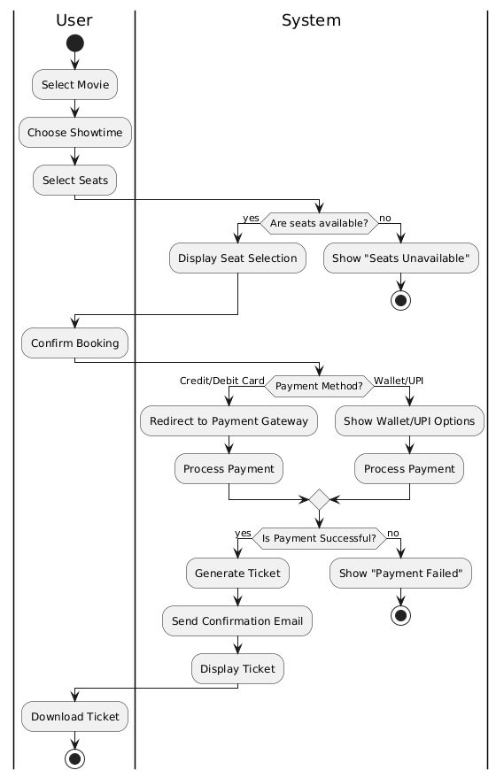

3.2 USE CASE DAIGRAM
The Use Case Diagram illustrates how users interact with the system in order to accomplish certain goals in a Movie Ticket Booking System. Below is a concise overview of the system.
Performers:Customer: An individual engaging with the system to reserve tickets.System: The backend responsible for handling the booking process.Payment Gateway: An external service that manages the payment procedure.
Demonstrations of Usage:Explore our selection of movies: Customers have the ability to search for and watch movies that are currently available.Choose a showtime: The customer selects a date and time for the movie.Choose your seats: Customers can pick from the seats that are currently available for the selected show.Process Payment: The customer finalizes the payment using a seamlessly integrated payment gateway.Create Ticket: The system generates a booking confirmation along with a ticket.You have the option to cancel your booking if necessary.Explore your booking history at your convenience by accessing previous reservations made.Connections:The main participant engaging with the system is the Customer, while the System interacts with the Payment Gateway when processing payments.The relationships of Includes and Extends determine when specific use cases are either essential or optional in relation to others.

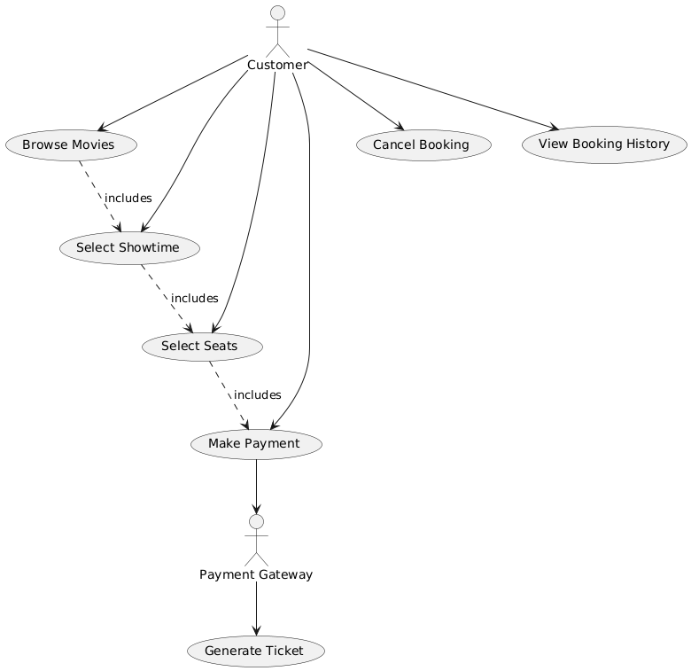

3.3 SEQUENCE DAIGRAM
A Sequence Diagram captures the dynamic exchange between various components (objects or actors) as it unfolds, depicting their communication flow in achieving a particular objective. The primary interactions in the Movie Ticket Booking System revolve around the customer, the system, and the payment gateway.Important interactions in the sequence diagram:The customer begins the booking process by choosing a movie, showtime, and seats.The system verifies the seat availability and proceeds to confirm the booking.The customer smoothly moves forward to complete the payment via the Payment Gateway.After the payment has been confirmed, the System will produce a ticket and promptly send a confirmation to the customer.

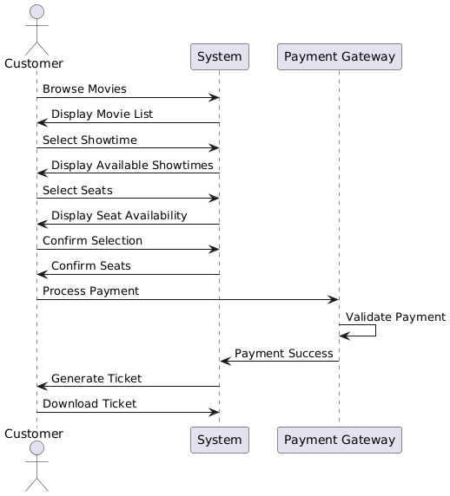

3.4 STATE CHAT DAIGRAM
A State Chart Diagram, also referred to as a State Machine Diagram, illustrates the various states of an object, such as a movie ticket booking, and the transitions between them that are initiated by events.In the Movie Ticket Booking System, the booking's status transitions between different stages in response to user interactions and system feedback. Here is a simplified overview of the stages and actions related to reserving a movie ticket.Primary locations for reserving movie tickets:Idle refers to the initial state when no action has been initiated.Chosen film: The user makes a selection from the available movies.The chosen movie will have its showtime selected by the user.Chosen seats: The user picks their desired seats from the available options.Payment is pending as the system is currently waiting for the customer to finalize the payment transaction.Payment confirmed: Your payment has been successfully processed.The booking has been successfully confirmed as the system has generated the ticket and confirmed the reservation.Booking Cancelled: The booking has been canceled by the customer at any point of the process.Smooth Transition:When a user selects a movie, their choice transitions smoothly from being idle to being the selected movie.When a showtime is selected, the movie selection will be updated accordingly.When the user selects seats, the chosen seats transition smoothly from Showtime Selected to Seats Selected.From choosing seats to awaiting payment processing after selecting the seats.Moving smoothly from Payment Pending to Payment Successful once the payment has been successfully processed.The status transitions smoothly from Payment Successful to Booking Confirmed upon generation of the ticket.The booking is eligible for cancellation at any point, transitioning it to the state of Booking Canceled

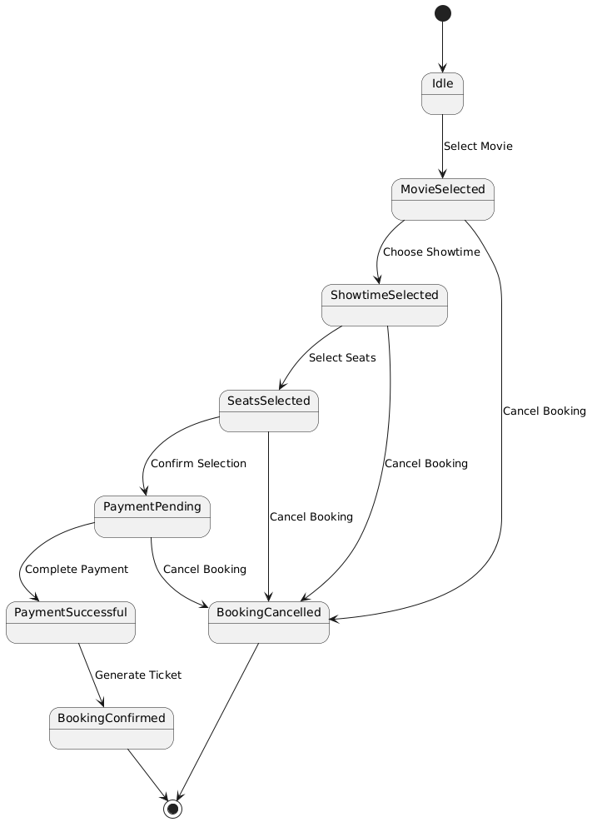
3.5 CLASS DAIGRAM
A Class Diagram elegantly embodies the stationary framework of a system, displaying its classes, along with their attributes, methods, and relationships. Within the framework of a Movie Ticket Booking System, primary classes could consist of Movie, Showtime, Seat, Customer, Payment, Booking, and Ticket.Types of classes and their characteristics:Film.Characteristics of a movie include movieID, movieName, duration, and genre.Procedures: retrieveInformation(), showcaseFilms()Time to showcase.Characteristics include: showtimeID, movieID, startTime, endTimeProcedures: acquireShowtimes(), optShowtime()Chair:Characteristics: seatID, seatNumber, status (Available/Booked)Operations available are seat reservation and availability verification.Client:Characteristics are: customerID, name, email, phoneNumber.Functions include searching for movies, booking tickets, and making payments.Reservation:The following attributes are part of the system: bookingID, customerID, showtimeID, seats[], and totalAmount.Procedures: validateReservation(), revokeReservation().Payment can be made using various methods.Characteristics include paymentID, amount, paymentMethod, and paymentStatus.Functions include processPayment() and verifyPayment().Admit:Characteristics include ticketID, bookingID, customerID, showtimeID, and an array of seat numbers.Procedures: createTicket(), transmitAcknowledgement().Interpersonal Connections:The customer currently has numerous bookings on file.Booking offers a variety of seating options.Making a booking involves making a payment.Making a booking leads to the creation of a ticket.Showtime is associated with a film..

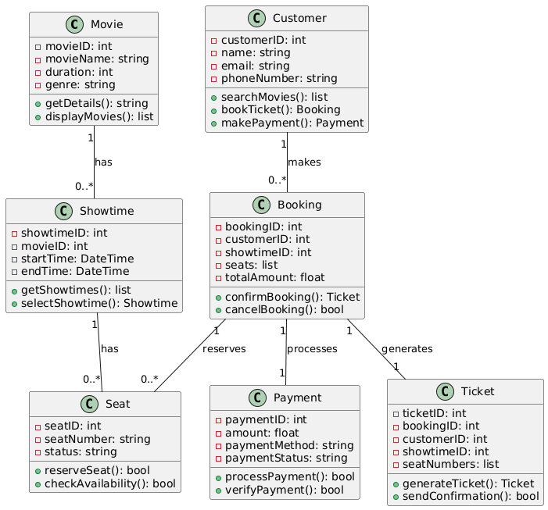

CHAPTER 4:BLACK BOX TESTING
Testing performed without any knowledge of the internal workings of the system is known as Black Box Testing.Black Box Testing examines the system's functionality against predetermined requirements, without delving into the internal mechanisms that drive its behavior.Essential principles in the realm of Black Box Testing:The system undergoes testing by considering its inputs and outputs.Testers lack access to the internal code or logic.Ensures that the system functions as intended for a diverse range of inputs.

4.1Equivalence Partitioning(Age Range: 18-60):
Equivalence Partitioning involves segmenting the input data into partitions that the system can handle uniformly. Every partition signifies a group of acceptable or unacceptable values. When testing one value from a partition, it is presumed that the entire partition will exhibit similar behavior.Example of Equivalence Partitioning for Age Range of 18-60:In a system requiring users to input their age, the acceptable age span falls within 18 to 60 years.Acceptable age range is from 18 to 60.Invalid age ranges have been identified as those below 18 and above 60.

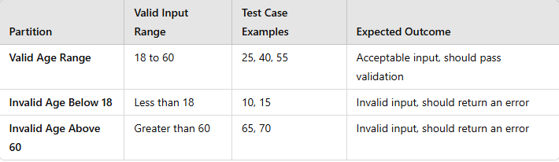

4.2 Boundary Value Analysis (BVA):(Age Range: 18-60):

Boundary Value Analysis is centered on testing the extremities or limit values within input ranges. It is commonly believed that errors tend to occur more frequently at the edges of input ranges.Illustrative Example of Boundary Value Analysis for Age between 18 and 60:The age input validation requires values within the boundaries of 18 (lower limit) and 60 (upper limit). It is important to test with values precisely at the boundaries, such as 18 and 60.Test the values just beyond the established boundaries (17 and 61) to confirm that the system properly rejects them.Experiment with values slightly below the boundaries (19 and 59) to verify the system's ability to handle values within the acceptable range.

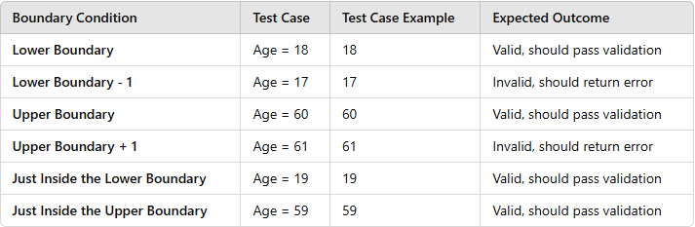

- CONCLUSION

To wrap it up, Black Box Testing is essential for confirming the functionality of a system without examining its internal code. This testing approach emphasizes assessing the system's performance by analyzing its input and output, guaranteeing that it adheres to the necessary criteria and specifications. Equivalence Partitioning and Boundary Value Analysis (BVA) are both effective methods utilized in Black Box Testing to enhance test case generation and amplify test coverage.Equivalence Partitioning streamlines the test case quantity by grouping inputs into equivalence classes. Testing a single value from each class is adequate to confirm the system's functionality for all values in that class. This method guarantees that the system effectively manages various input categories while reducing repetition.Boundary Value Analysis, conversely, focuses on the borders or limits of input ranges, where errors are prone to happen. Boundary Value Analysis (BVA) is able to uncover defects that could be missed using conventional input values by specifically testing values that are slightly inside and outside the boundaries.When combined, these techniques offer a thorough and effective testing strategy that reduces the number of test cases while still guaranteeing full coverage of crucial input scenarios. Collaboratively, they guarantee that the system operates effectively with both common and uncommon inputs, providing a strong and dependable user experience.

